**UNION & UNION ALL**

* Combines the result set of two or more queries into a single result set.
* Number of columns and sequence of columns must be the same in all queries.
* The data types must be compatible.
* **UNION**: - allows join multiple datasets into one dataset and will remove any duplicates that exist. Performing a DISTINCT operation across all columns in the result set.
* **UNION ALL**: - allows you to join multiple datasets into one dataset, but it does not remove any duplicate rows.
* Column names for the final result set are taken from the first query.
* ORDER BY clause can only be issued for the overall result set and not within each individual result set
* GROUP BY and HAVING clauses can only be issued for each individual result set and not for the overall result set
* Due to difference in query execution time, UNION ALL is smaller than UNION, which means former runs faster than later.

**Syntax**

1. **Select Col1, Col2, Clo3 from Table1**
2. **UNION**
3. **Select Col1, Col2, Clo3 from Table2**

**Syntax**

1. **Select Col1, Col2, Clo3 from Table1**
2. **UNION  ALL**
3. **Select Col1, Col2, Clo3 from Table2**

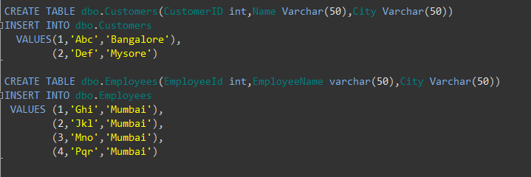

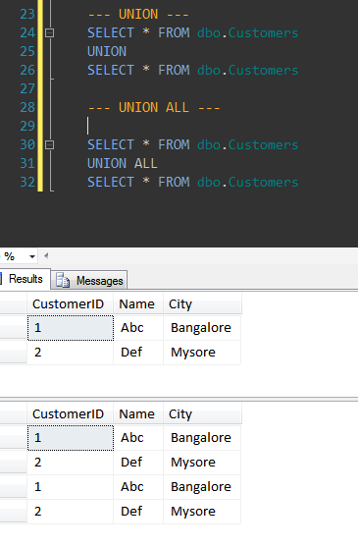

**Mismatch in the No of Columns in the select queries combined by the UNION Operator:**

|  |
| --- |
|  |



**RESULT:**  
Msg 205, Level 16, State 1, Line 1 All queries combined using a UNION, INTERSECT or EXCEPT operator must have equal number of expressions in their target lists.

Reason for the above error is: First statement of the UNION has two columns in the select list whereas Second statement has 3 columns (i.e. * means all the columns in the Customers table)

**No of columns matching but mismatch in the data type of the columns**

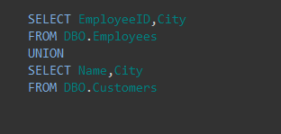

**RESULT:**  
Msg 245, Level 16, State 1, Line 1 Conversion failed when converting the varchar value ‘Monty Biradar’ to data type int.

Reason for this error is: first column in the first statement of the UNION is of type INT and the first column in the Second statement is VACHAR, due to this incompatible data type we are seeing an error here.

Now we can re-write this query to work as below.

